CHIRANJIB NAIYA 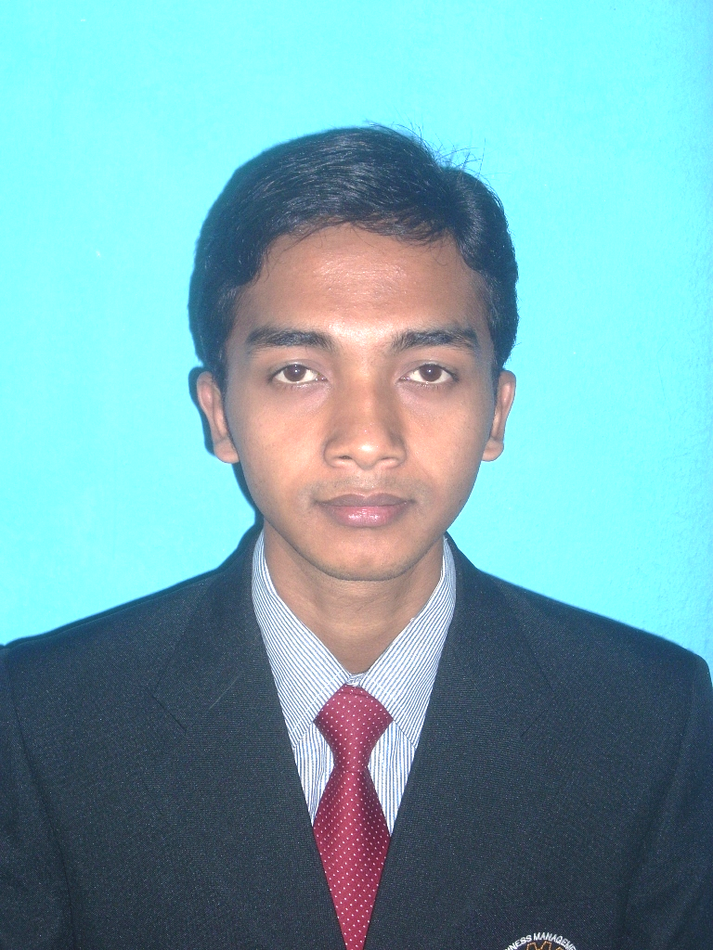
Garia, Nabagram, panchpota
Kolkata – 700152, West Bengal
Mobile No:- 9153503251
Email:- chiranjib.naiya@gmail.com
OBJECTIVE
- Seeking challenging assignments in a reputed organization which provides opportunities for professional growth and advancement and where I can utilize my experience and acquired skills towards becoming a valuable team member.
ACADEMIA AND PROFESSIONAL CREDENTIALS
- I passed the secondary examination in the year 2002 from W.B.B.S.E. with 57% mark.
- I passed the higher secondary examination in the year 2004 from W.B.C.H.S.E. with 46% mark.
- I have completed 4th semester of the Bachelor of Business Administration (HONOURS) program for the session of 2008-2011 from W.B.U.T.
PERSONAL INFORMATION
- Date of Birth:- 18TH February 1986
- Martial Status:- Single
- Nationality:- Indian
- Sex:- Male
- Language Known:- Hindi, Bengali, English
- I known Computer Basic course.
WORK EXPERIENCE
- I worked as a sales executive of S.B.I. credit card for 6 month.
- I worked as Certified Financial Consultant of H.D.F.C. Standard Life Insurance for 9 month.
- I worked as an investigator of S.S.E.S.S. for 5 month.
- I worked as a sales executive in a reputed showroom for 4 month.

DATE ……………………
PLACE……………………..
….……………………………
(SIGNATURE)

