RESUME

Mr.A.Vairamuthu  10/57,Madathupatti st,  Rice mill road,  Rajapalayam,  Virudhunagar Dist,  Pin Code-626117. | E-Mail ID : vairamuthu512@gmail.com  Mobile no : 9894015210

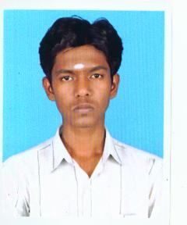

Objective:
Looking for a challenging and responsible opportunity, explore strengths and potentials in a professional organization to meet employers’ expectations
Academic Career:
Examination | School/College | Board/University | Period of course | Percentage obtained
B.SC (CS) | Arulmigu kalasalingam college of arts and science, Krishnankoil. | M.K.University | 2009-2012 | 79.70(UPTO 5th  SEMESTER )
HSC | S.S.govt.boys.hr.school,  Rajapalayam. | State | 2007-2009 | 73.9%
SSLC | A.I.G.M.hr.school,  Rajapalayam. | State | 2006-2007 | 75.2%

Technical Skills:
Operating Systems | : MSDOS, WINDOWS XP
Languages Known | : C, C++, JAVA, VB
Data Bases | : DBMS
Web Tools | : HTML, JAVA Script,VB Script
Design Tools | : Photoshop, Flash

Utilities : Microsoft office

Technical Area of Interest:

C++

Project Details (Under Graduate):

Project title : Library Information Maintenance System (LMIS)

Duration : 6months

Front End : VB 6.0

Back End : MS-Access

Other Activities:
- Attend Nss camp
- Attend Blood donation camp
- Participate college cultural events

Achievements:

Participated inter-collegiate competition for IT-Quiz and got Third Price.

Experience:

Two year working with sun computer education in Rajapalayam.

Strengths:
- Self confidence
- Both success and failure will accept

Personal profile:

Name : A.Vairamuthu

Date of birth : 20 Apr 1992

Languages known : Speak-Tamil,English,Telugu

Write-Tamil, English

Declaration

I hereby declare that the above-mentioned information is correct up to my knowledge and I bear the responsibility for the correctness of the above-mentioned particulars.
Place : yours sincerely,
Date : [A.Vairamuthu]

